Question1

package day8.selenium;

import org.testng.annotations.Test;

import org.testng.annotations.BeforeTest;

import org.openqa.selenium.By;

import org.openqa.selenium.WebDriver;

import org.openqa.selenium.WebElement;

import org.openqa.selenium.firefox.FirefoxDriver;

import org.testng.Assert;

import org.testng.annotations.AfterTest;

public class Ca1 {

WebDriver driver;

@BeforeTest

public void beforeTest() {

driver=new FirefoxDriver();

}

@Test

public void Test1() throws InterruptedException {

String url="https://www.saucedemo.com/";

driver.get(url);

driver.manage().window().maximize();

Thread.sleep(5000);

System.out.println("opened");

driver.findElement(By.xpath("//*[@id=\"user-name\"]")).sendKeys("standard_user");

Thread.sleep(2000);

driver.findElement(By.xpath("//*[@id=\"password\"]")).sendKeys("secret_sauce");

driver.findElement(By.xpath("//*[@id=\"login-button\"]")).click();

Thread.sleep(5000);

System.out.println("selected");

driver.findElement(By.xpath("//*[@id=\"add-to-cart-sauce-labs-backpack\"]")).click();

driver.findElement(By.xpath("//*[@id=\"shopping_cart_container\"]/a")).click();

Thread.sleep(2000);

System.out.println("cart viewed");

WebElement txt=driver.findElement(By.xpath("//*[@id=\"item_4_title_link\"]/div"));

String txt1=txt.getText();

System.out.println(txt1);

WebElement price=driver.findElement(By.xpath("//*[@id=\"cart_contents_container\"]/div/div[1]/div[3]/div[2]/div[2]/div"));

String pr1=price.getText();

System.out.println(pr1);

System.out.println("Contents checked");

driver.findElement(By.xpath("//*[@id=\"checkout\"]")).click();

Thread.sleep(2000);

System.out.println("checkout");

String p1=driver.getCurrentUrl();

String ap1="https://www.saucedemo.com/checkout-step-one.html";

Assert.assertEquals(p1, ap1);

driver.findElement(By.xpath("//*[@id=\"first-name\"]")).sendKeys("abcd");

driver.findElement(By.xpath("//*[@id=\"last-name\"]")).sendKeys("efgh");

driver.findElement(By.xpath("//*[@id=\"postal-code\"]")).sendKeys("12345");

Thread.sleep(2000);

driver.findElement(By.xpath("//*[@id=\"continue\"]")).click();

System.out.println("details");

Thread.sleep(2000);

String p2=driver.getCurrentUrl();

String ap2="https://www.saucedemo.com/checkout-step-two.html";

Assert.assertEquals(p2, ap2);

Thread.sleep(2000);

String title=driver.getTitle();

String atitle="Swag Labs";

Assert.assertEquals(title,atitle);

driver.findElement(By.xpath("//*[@id=\"finish\"]")).click();

}

@AfterTest

public void afterTest() throws InterruptedException {

Thread.sleep(2000);

driver.quit();

}

}

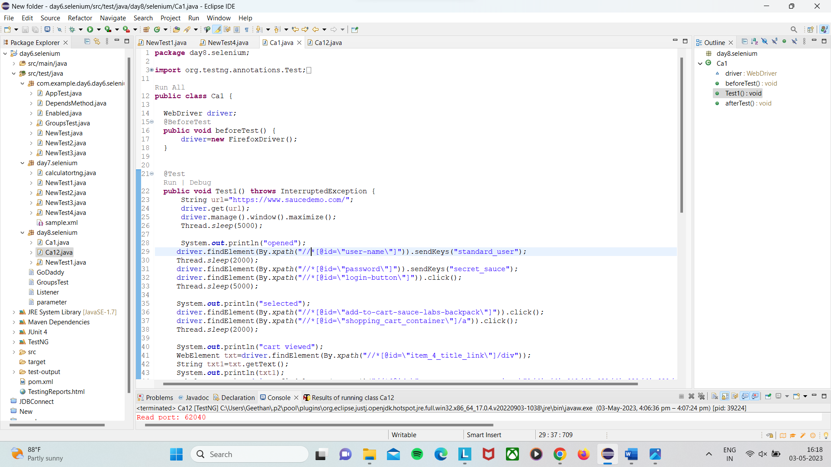

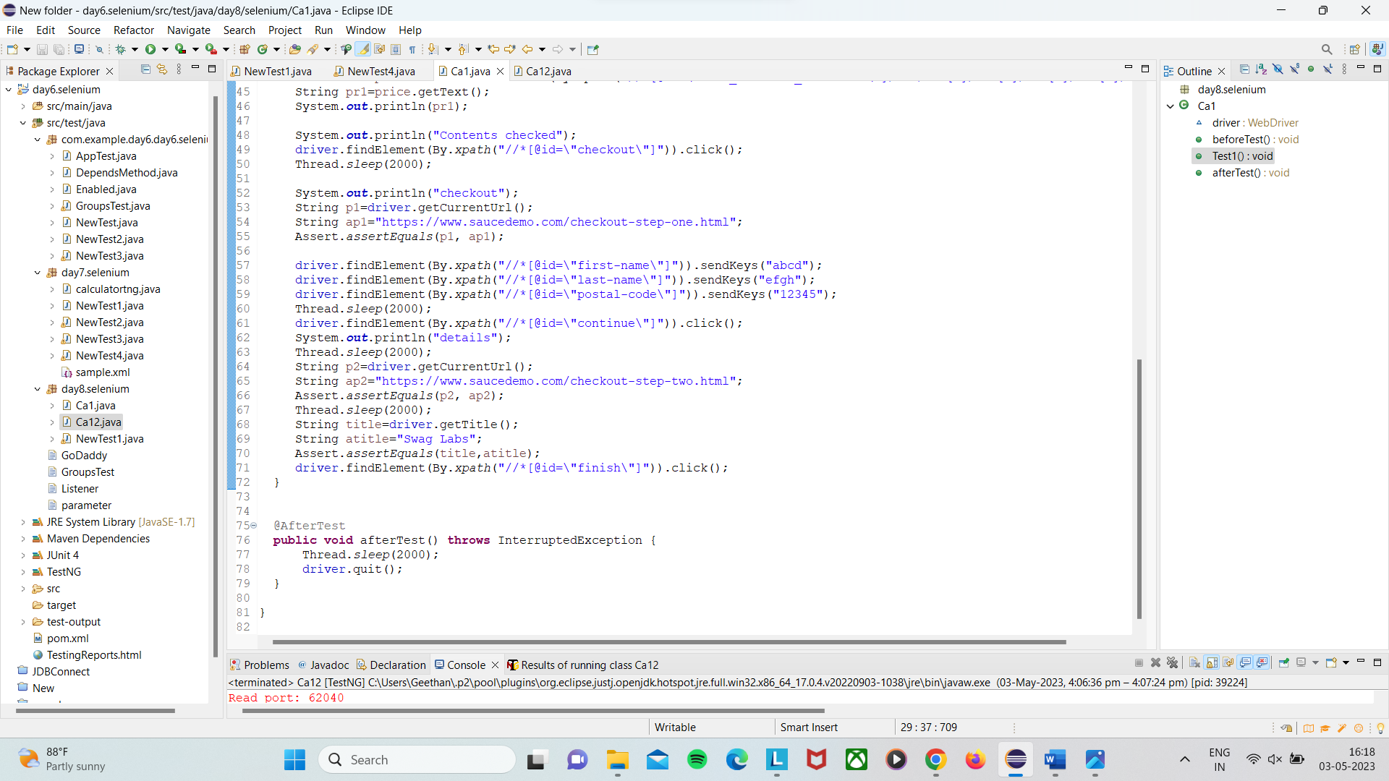

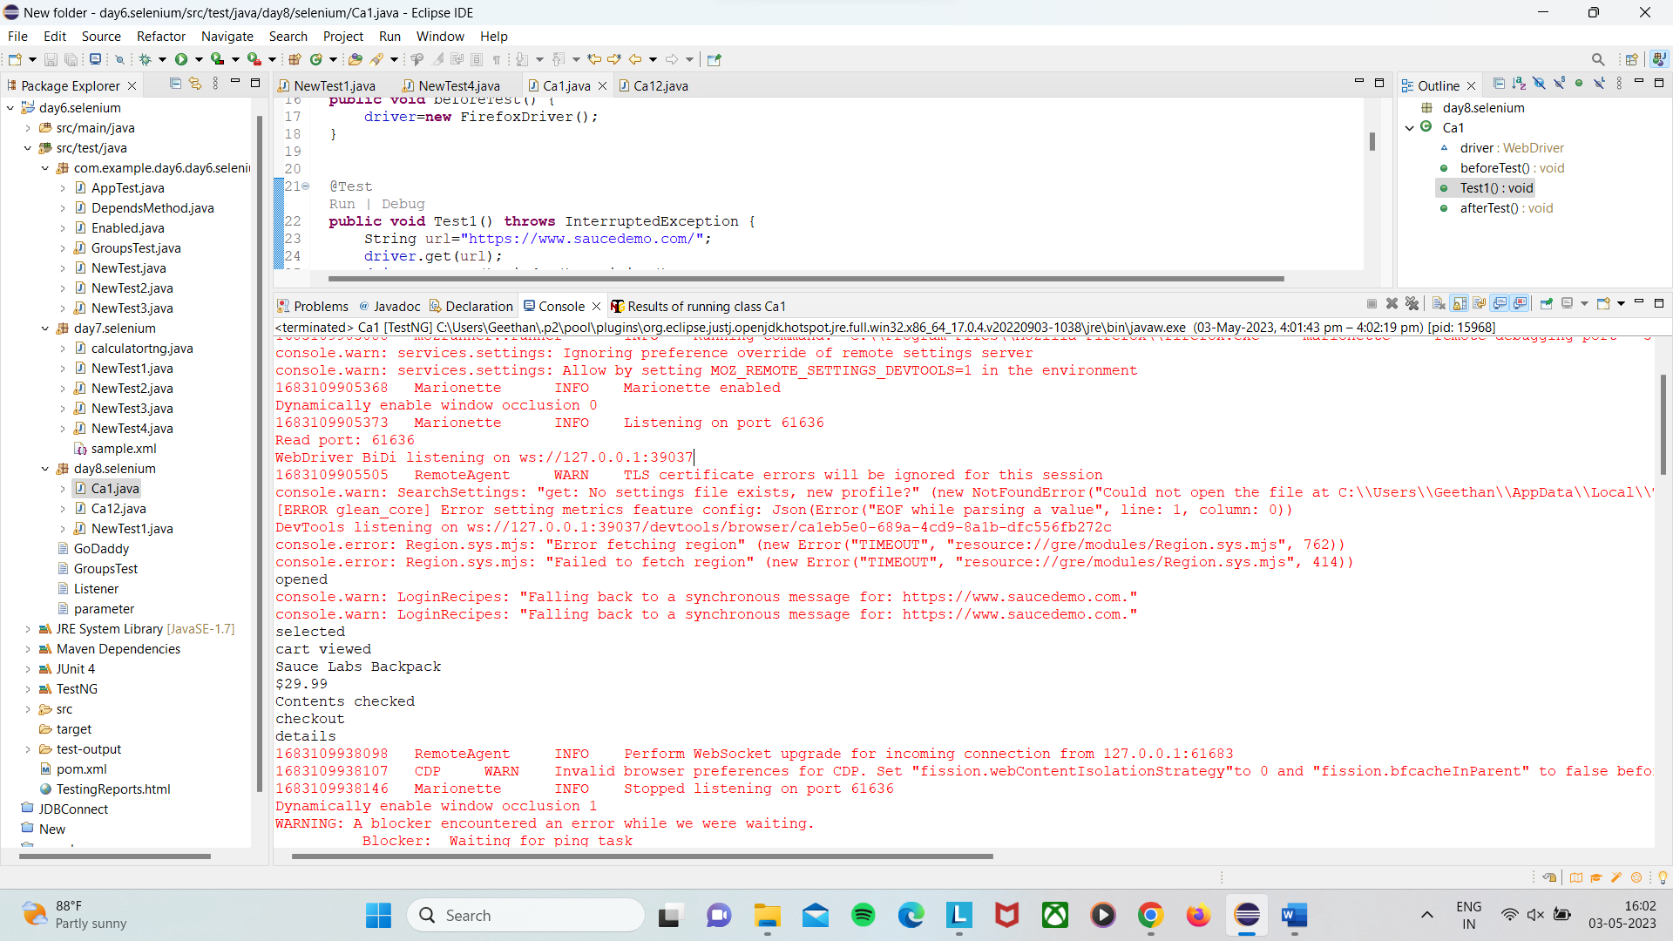

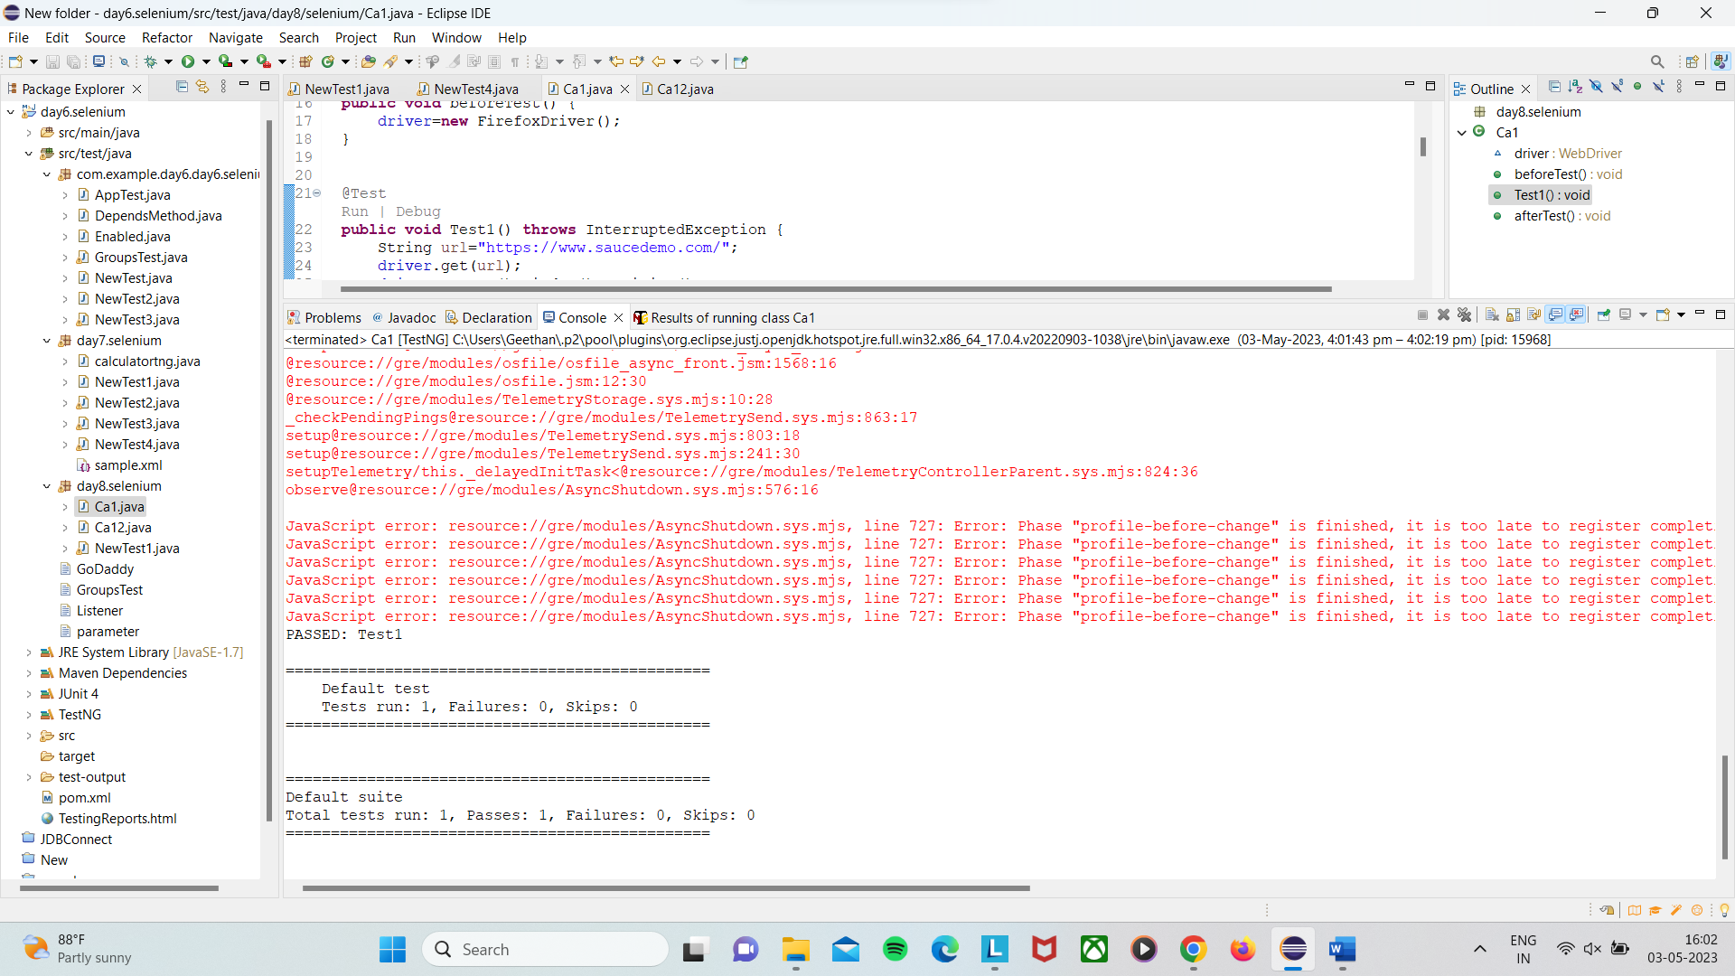

Question 2

package day8.selenium;

import org.testng.annotations.Test;

import org.testng.annotations.BeforeTest;

import org.openqa.selenium.By;

import org.openqa.selenium.WebDriver;

import org.openqa.selenium.WebElement;

import org.openqa.selenium.firefox.FirefoxDriver;

import org.testng.annotations.AfterTest;

public class Ca12 {

WebDriver driver;

@BeforeTest

public void beforeTest() {

driver=new FirefoxDriver();

}

@Test

public void Test1() throws InterruptedException {

String url="https://www.saucedemo.com/";

driver.get(url);

driver.manage().window().maximize();

Thread.sleep(5000);

System.out.println("opened");

driver.findElement(By.xpath("//*[@id=\"user-name\"]")).sendKeys("standard_user");

Thread.sleep(2000);

driver.findElement(By.xpath("//*[@id=\"password\"]")).sendKeys("secret_sauce");

driver.findElement(By.xpath("//*[@id=\"login-button\"]")).click();

Thread.sleep(5000);

driver.findElement(By.xpath("//*[@id=\"header_container\"]/div[2]/div/span/select")).click();

Thread.sleep(2000);

driver.findElement(By.xpath("//*[@id=\"header_container\"]/div[2]/div/span/select/option[1]")).click();

WebElement az1=driver.findElement(By.xpath("//*[@id=\"item_4_title_link\"]/div"));

String taz1=az1.getText();

System.out.println(taz1);

driver.findElement(By.xpath("//*[@id=\"header_container\"]/div[2]/div/span/select")).click();

Thread.sleep(2000);

driver.findElement(By.xpath("//*[@id=\"header_container\"]/div[2]/div/span/select/option[2]")).click();

WebElement az2=driver.findElement(By.xpath("//*[@id=\"item_3_title_link\"]/div"));

String taz2=az2.getText();

System.out.println(taz2);

driver.findElement(By.xpath("//*[@id=\"header_container\"]/div[2]/div/span/select")).click();

Thread.sleep(2000);

driver.findElement(By.xpath("//*[@id=\"header_container\"]/div[2]/div/span/select/option[3]")).click();

WebElement az3=driver.findElement(By.xpath("//*[@id=\"inventory_container\"]/div/div[1]/div[2]/div[2]/div"));

String taz3=az3.getText();

System.out.println(taz3);

driver.findElement(By.xpath("//*[@id=\"header_container\"]/div[2]/div/span/select")).click();

Thread.sleep(2000);

driver.findElement(By.xpath("//*[@id=\"header_container\"]/div[2]/div/span/select/option[4]")).click();

WebElement az4=driver.findElement(By.xpath("//*[@id=\"inventory_container\"]/div/div[1]/div[2]/div[2]/div"));

String taz4=az4.getText();

System.out.println(taz4);

}

@AfterTest

public void afterTest() throws InterruptedException {

Thread.sleep(2000);

driver.quit();

}

}

